Software Interface Specification

Voyager 2 Uranus
Radio Science
Raw Data Archive (Parkes)

Prepared By

Richard Simpson

Version 1.0
11 April 2025

Change Log

Date | Sections Changed | Reason for Change | Revision
2025-04-11 | All | New document | 1.0

Contents

Change Log 2
Contents 3
Acronyms and Abbreviations 5
1 Introduction 6
1.1 Document Overview 6
1.2 Data Overview 6
1.3 Experiment Overview 6
1.4 Example Data 8
1.5 Applicable Documents 9
1.6 System Siting 9
1.6.1 Interface Location and Medium 9
1.6.2 Data Sources, Destinations, and Transfer Methods 10
1.6.3 Generation Method and Frequency 10
1.7 Assumptions and Constraints 11
1.7.1 Usage Constraints 11
1.7.2 Documentation Conventions 11
2 Interface Characteristics 12
2.1 Hardware Characteristics and Limitations 12
2.1.1 Special Equipment and Device Interfaces 12
2.1.2 Special Set-Up Requirements 12
2.2 Volume and Size 12
2.3 Labeling and Identification 12
2.3.1 External Labels 12
2.3.2 Internal Labels 12
2.4 Interface Medium Characteristics 12
2.5 Backup and Duplicates 12
3 Structure and Organization Overview 13
3.1 Logical Organization 13
3.1.1 Bundles and Collections 13
3.1.2 Products 14
3.1.2.1 PODR and Browse Products 14
3.1.2.2 Frequency Calibration Products 15
3.1.2.4 Geometry Products 15
3.1.2.5 Document Products 15
3.1.3 Versioning 15
3.1.4 Labels 15
3.2 Physical Organization 16
3.2.1 File Naming and Conversions 16
3.2.1.1. ODR and Browse Product File Names 16
3.2.1.2 Frequency Calibration Product File Names 16
3.2.1.4 Geometry Product File Names 16
3.2.1.5 Document Product File Names 17
3.2.2 File Conversions 17
3.2.3 Directories 17
4 Support Staff and Cognizant Personnel 18
4.1 Planetary Data System 18
5 Errata 18
5.1 Bad or Missing Data 18
5.1.1 Corrupted Records 18
5.1.2 Incorrect Record Header Values 18
5.2 Buffer delays 18
Appendix A Tape Log – Voyager 2 at Uranus (Parkes) 19
Appendix B Time Line – Voyager 2 at Uranus (Parkes) 22

Acronyms and Abbreviations

ASCII American Standard Code for Information Interchange
CCT computer-compatible tape
DSN NASA Deep Space Network
DSS Deep Space Station (antenna and associated facilities)
GB gigabyte
HGA high-gain antenna
JPEG, JPG Joint Photographic Experts Group
JPL Jet Propulsion Laboratory
ksps thousand samples per second
LID logical identifier
LIDVID versioned logical identifier
MB megabyte
MHz megaHertz
NASA National Aeronautics and Space Administration
NAIF Navigation Ancillary Information Facility
NSSDC National Space Science Data Center (since renamed NSSDCA)
NSSDCA National Space Science Data Coordinated Archive
OCC occultation
PDS Planetary Data System
PDS4 PDS Standards, version 4
PODR Parkes Original Data Record
RCP right circular polarization
RDA Raw Data Archive
RMS Ring Moon Systems (PDS discipline node)
RS radio science
RSS Radio Science Subsystem
RST Radio Science Team
s/c spacecraft
SCAT scatter (as in ring scattering observations)
SIS Software Interface Specification
SPICE information system produced by the NAIF Team
VG, VGR Voyager
VG2 Voyager 2
VG2U Voyager 2 Uranus
VID version identifier
XML eXtensible Markup Language

1 Introduction

1.1 Document Overview

This Software Interface Specification (SIS) describes the format and content of the Voyager 2 Uranus (VG2U) Radio Science (RS) Raw Data Archive (RDA) (Parkes). These data were collected at Parkes Observatory in Australia, were delivered to the Voyager Radio Science Team for analysis, and have since been delivered to the Planetary Data System (PDS) [1] for archive. This document applies only to the data collected using NASA Deep Space Network (DSN) equipment temporarily installed at Parkes (DSN identifier DSS-49) during the Voyager 2 encounter with Uranus in January 1986. A different document describes data collected at the DSN station near Canberra, Australia.

1.2 Data Overview

The data are organized into one PDS4 bundle [2]. Within the bundle are several collections, summarized in Table 1.2-1 [3]. Within collections are individual products, each typically consisting of one or a few data files plus a descriptive label written in XML. The observational data are in 56 files containing Parkes Original Data Records (PODRs) in the data_podr collection. Binary files have been translated to ASCII. Summary data plots are in the browse collection.

After peer review, the bundle was posted to the PDS Ring Moon Systems (RMS) web site. Partially processed data had previously been delivered to the National Space Sciences Data Center (NSSDC) by the Voyager RS Team (RST) [4]. The original raw data had never been previously archived.

1.3 Experiment Overview

The observing geometry is illustrated in Figure 1.2-1. The spacecraft transmitted unmodulated carriers at S- and X-band referenced to the output frequency of an on-board ultra-stable oscillator (USO). As the signals passed through the atmosphere and/or rings of Uranus, they were refracted, absorbed, and/or scattered. Refraction may be interpreted in terms of the temperature and pressure in a neutral atmosphere or the electron density in an ionosphere. Changes in signal intensity may be attributed to refraction, diffraction, and/or presence of absorbing materials in the atmosphere or to size and density of particles in a ring.

The observable at Parkes was the voltage signal from an X-band receiver connected to a right-circularly polarized antenna feed. The receiver translated the original signal at approximately 8420 MHz to a baseband 0-35 kHz output. This signal was sampled by four 8-bit 20 ksps analog-to-digital converters (ADCs) operating sequentially for an effective single channel sampling rate of 80 ksps. The ADC output was recorded on computer-compatible tapes (CCTs), which were returned to NASA’s Jet Propulsion Laboratory (JPL) for copying and distribution to Voyager Radio Science Team (RST) members. Dual-polarization S- and X-band signals received at NASA DSN antennas near Canberra (Australia) are being archived separately. Early processing suggested that Parkes phase instability would preclude arraying [9], an early reason for using two observatories.

Time lines for acquisition of Uranus data and acquisition of test data can be found in Appendix B.

Table 1.2-1: Collections within the Voyager 2 Uranus Radio Science (Parkes) RDA Bundle
(bundle_id = voyager2_rss_uranus_49xr_raw)
collection_id | Product Contents | Number of Products
data_podr | 8-bit samples of radio receiver output (binary and ASCII) | 56
browse | quick-look plots illustrating content of each PODR (JPEG) | 56
calib_freq | estimates of USO frequency | 1
context | references to descriptive materials (context products), which are maintained elsewhere | 0
geometry | geometry files in non-SPICE formats, including spacecraft antenna pointing reconstruction and state vectors in the Voyager 2 frame | 2
document | documents relevant to use of data files | 7

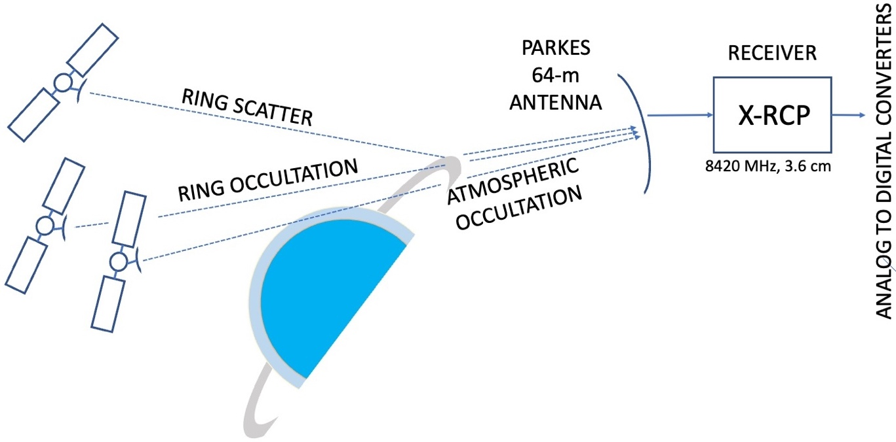
Figure 1.2-1. Observational geometry for data collection at Uranus. As the spacecraft passed behind the planet, its radio signals were refracted by the atmosphere, causing an apparent Doppler shift at the receiving station. During occultation by Uranus’ rings, the signal’s intensity was reduced and its frequency was spread when scattered by ring particles.

1.4 Example Data

Figure 1.2-2 is an example of partially processed data from the Uranus radio occultation ingress. There is one such four-panel plot (in the browse collection) for each of the 56 PODR products in the bundle. Occultations can be seen in the lower left panel of the figure; the ionospheric occultation is at 23.3 hours and the occultation by the neutral atmosphere begins shortly before 23.35 hours
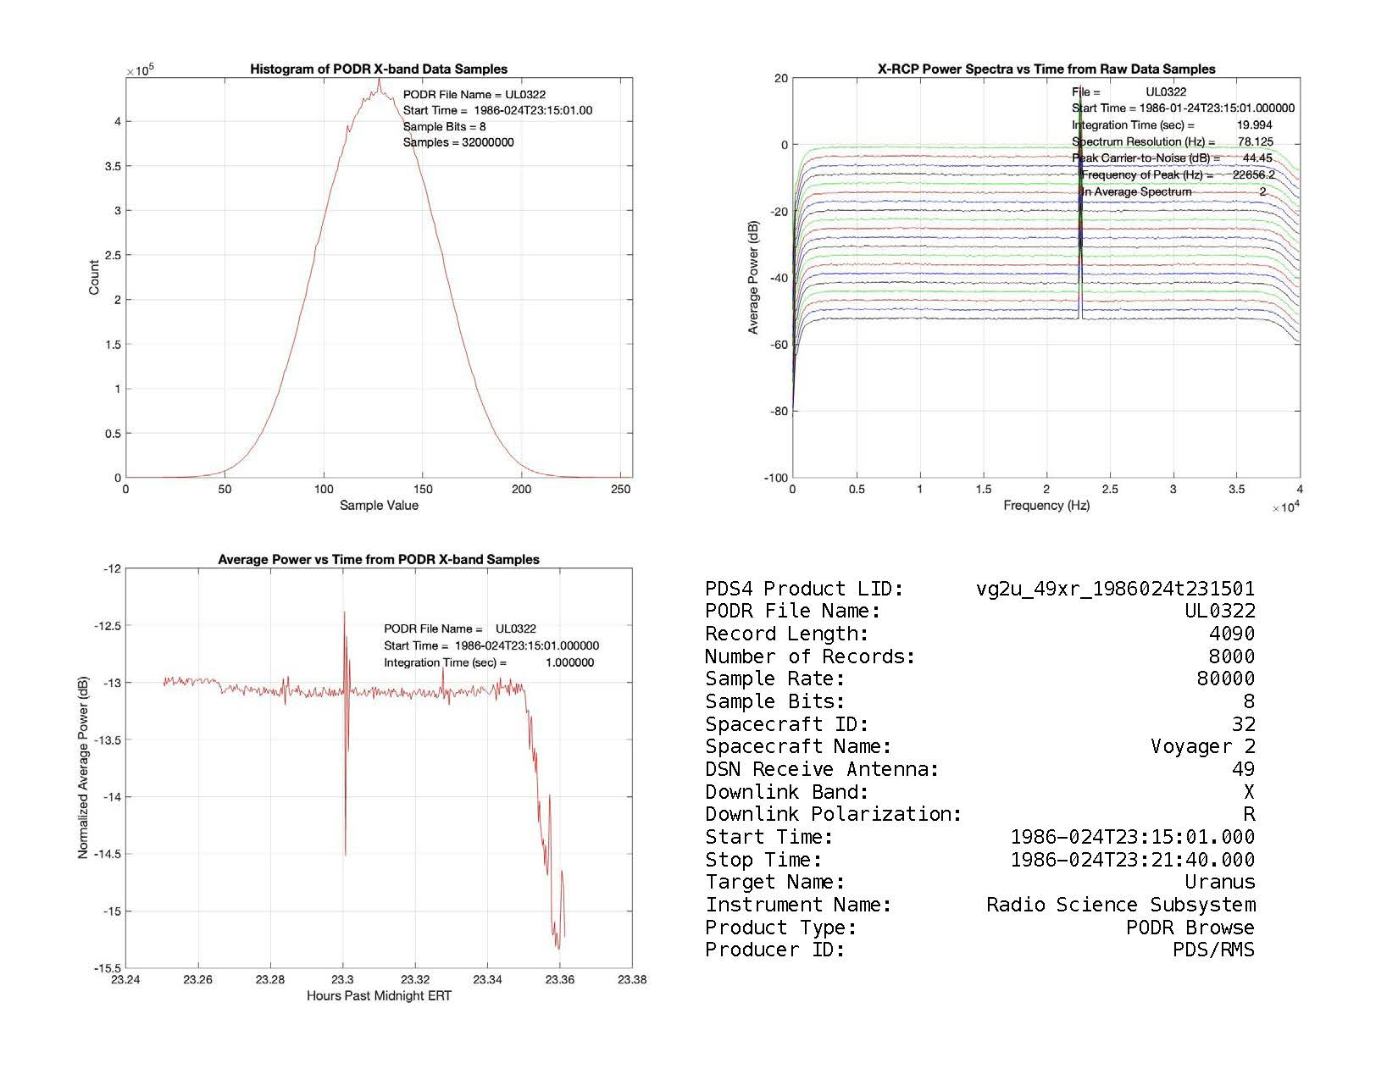
Figure 1.2-2: Example product from the Parkes browse collection showing the ingress ionospheric and neutral atmospheric occultations. Upper left: histogram of raw data sample values. Lower left: Power versus time in sample values — one second averages of squared sample values after removal of the mean. Upper right: Power spectra (0-40 kHz); each trace is an average over 20 seconds. Time increases from bottom to top. Lower right: an ASCII summary of the observing configuration.

Derivatives of these observations include the temperature-pressure structure of Uranus’ neutral atmosphere, electron density profiles of Uranus’ ionosphere, and opacities of and size distribution of particles in the Uranian rings [5]. The data in this bundle could also be used to supplement radio tracking data acquired for investigations of Uranus’ mass and gravity field.

1.5 Applicable Documents

This SIS references the following URLs and documents:

[1] https://pds.nasa.gov/home/about/

[2] Planetary Data System – Data Design Working Group, “PDS4 Concepts, version 1.21.0”, doi: 10.17189/5sagaf16, October 2023 (https://pds.nasa.gov/datastandards/documents/concepts/Concepts_1.21.0.pdf)

[3] —, “Planetary Data System Standards Reference, version 1.21.0”, doi: 10.17189/j5bz-bj10, October 2023 (https://pds.nasa.gov/datastandards/documents/sr/current/StdRef_1.21.0.pdf)

[4] https://nssdc.gsfc.nasa.gov/nmc/dataset/display.action?id=PSPA-00402

[5] Tyler, G. L., D. N. Sweetnam, J. D. Anderson, J. K. Campbell, V. R. Eshleman, D. P. Hinson, G. S. Levy, G. F. Lindal, E. A. Marouf, and R. A. Simpson, "Voyager 2 Radio Science Observations of the Uranian System: Atmosphere, Rings and Satellites," Science, 233, pp. 79-84, 1986.

[6] RSC-11-9, DSN Radio Science Subsystem Interface, Original Data Record, Document 820-013, Rev. A, DSN System Requirements, Detailed Interface Design (urn:nasa:pds:radiosci.documentation:dsn.rsc-11-9:1982-03-01). https://pds-geosciences.wustl.edu/radiosciencedocs/urn-nasa-pds-radiosci_documentation/dsn_rsc-11-9p/dsn_rsc-11-9p.1982-03-01.pdf

[7] Simpson, R. A., Interpretation and Use of Binary RSC-11-9 (Parkes) Data, Planetary Data System, 2024 (urn:nasa:pds:radiosci.documentation:dsn.rsc-11-9p:rsc-11-9p_unpack). https://pds-geosciences.wustl.edu/radiosciencedocs/urn-nasa-pds-radiosci_documentation/dsn_rsc-11-9p/rsc-11-9p_unpack.pdf

[8] Berman, A. L., and G. L. Tyler, Reconstruction of Downlink Frequency from Open-Loop Data, JPL IOM ALB-78-133, 22 November 1978. (urn:nasa:pds:radiosci.documentation:document:berman.1978)

[9] Gresh, D. L., E. A. Marouf, G. L. Tyler, P. A. Rosen, and R. A. Simpson, "Voyager Radio Occultation by Uranus' Rings. 1. Observational Results," Icarus, 78, pp. 131-168, 1989.

1.6 System Siting

1.6.1 Interface Location and Medium

The storage medium, including at least two backups, is determined by the PDS RMS Node. The user interface is through the PDS RMS web site (https://pds-rings.seti.org).

1.6.2 Data Sources, Destinations, and Transfer Methods

This bundle is an aggregations of products generated by various elements of the DSN, the Voyager Project, the Voyager Radio Science Team, the Voyager Radio Science Support Team, and others. The original data were delivered on CCTs to the Voyager Radio Science Team at Stanford University. The archival products have been delivered to PDS/RMS electronically.

1.6.3 Generation Method and Frequency

This bundle has one primary observational data type — the Parkes Original Data Record (PODR), stored in the data_podr collection (Table 1.2-1). PODRs are binary files. They were recorded originally at Parkes Observatory, delivered to the NASA DSN station in Canberra, and forwarded to NASA JPL where they were copied and distributed to members of the Voyager Radio Science Team. Except when there were tape validation errors, the copying and delivery to end users was completed within a few weeks of the observation and was not repeated. Original binary PODrs have been converted to ASCII for easier user access; see section 3.1.2.1 for details.

Quick-look plots showing contents of the PODRs were generated as JPEG and ASCII text files, which were inserted into a Microsoft Word document. Each Word document was saved in Adobe Portable Document format (PDF), converted to JPEG, and stored in the browse collection.

Estimates of the USO frequency at specific times during the mission for both Voyager 1 and Voyager 2 are included in the calib_freq collection as a memo in ASCII format. Programmable Oscillator Control Assembly (POCA) data gave receiver tuning frequencies, which are needed to determine the exact frequency of signals in the PODR files [6]; POCA data are included in the PODR files rather than as separate files in the calib_freq collection. See [8] for conversion of POCA values to sky frequency at Parkes.

The geometry collection includes (1) a pair of files (one binary, one ASCII) with position and velocity data for selected targets with respect to the spacecraft and (2) a pair of files (one binary, one ASCII) with reconstructed high-gain antenna pointing vectors, which were used by the Voyager Radio Science Team to interpret radio occultation data in the deep neutral atmosphere. Users of this archive seeking new or improved science results should consider downloading the latest reconstructions from PDS NAIF (https://naif.jpl.nasa.gov/pub/naif/VOYAGER/).

The document collection includes files which describe the Voyager mission, the radio science operations plan, the archive SIS (this document), and software for generating browse products. DSN documents which describe radio science data formats that are mission independent — for example, [6] — are included as secondary members of this document collection

1.7 Assumptions and Constraints

1.7.1 Usage Constraints

Access to the Voyager 2 Uranus RS RDA (Parkes) bundle is determined by PDS.

1.7.2 Documentation Conventions

1.7.2.1 Data Format Descriptions

Since formats vary widely among data/file types, users should consult product labels for details. Receiver samples are described by [6]; example conversions of binary to ASCII formats are given in [7].

1.7.2.3 Limits of This Document

This document applies only to the PDS4 bundle containing raw radio science data in RSC-11-9 format collected at Parkes during the Voyager 2 Uranus encounter [7].

2 Interface Characteristics

2.1 Hardware Characteristics and Limitations

2.1.1 Special Equipment and Device Interfaces

The Voyager 2 Uranus RS RDA (Parkes) bundle is posted on the PDS/RMS web site (https://pds-rings.seti.org). Users of the data must have access to systems which can connect with the web site.

2.1.2 Special Set-Up Requirements

None.

2.2 Volume and Size

Most original PODR data files contain 32.72 megabytes, and their ASCII translations have 251.2 MB; other files are small by comparison. There are 56 PODRs in the bundle, making the total volume approximately 16 GB.

2.3 Labeling and Identification

2.3.1 External Labels

There is no external labeling of the bundle; these archives are stored electronically on systems managed by the PDS RMS Node.

2.3.2 Internal Labels

Voyager 2 Uranus RS RDA (Parkes) bundles, collections, and products are identified by logical and version identifiers (LIDs and VIDs, respectively) constructed in accordance with PDS4 standards. These identifiers are described further in Section 3 of this document.

2.4 Interface Medium Characteristics

The Voyager 2 Uranus RS RDA (Parkes) bundle is posted on the PDS RMS Node web site; the storage media and methods are determined by PDS/RMS.

2.5 Backup and Duplicates

The entire content of the Voyager 2 Uranus RS RDA (Parkes) bundle is backed up following procedures developed by PDS/RMS in accordance with PDS policies.

3 Structure and Organization Overview

3.1 Logical Organization

The Voyager 2 Uranus RS RDA (Parkes) is organized into one bundle as specified in Table 1.2-1. The bundle has six primary/secondary collections (Table 1.2-2). The members of collections are data products, each including its own label written in the eXtensible Markup Language (XML). The members of each collection are listed in a collection Inventory, which is accompanied by an XML label. The bundle has a label which lists the member collections, but there is no separate inventory file. Figure 3.1-1 illustrates the logical structure for the bundle.

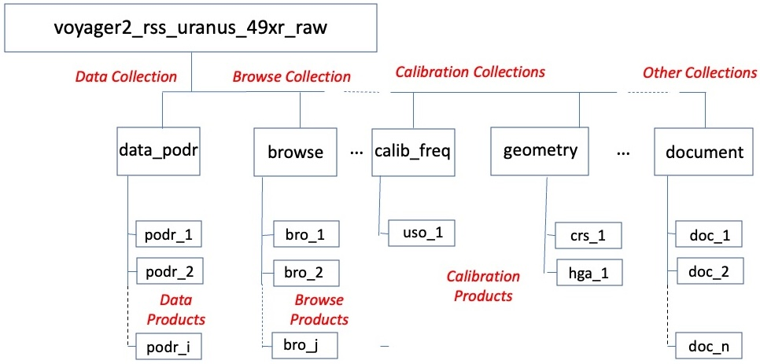
Figure 3-1.1. Logical structure of the Voyager 2 Uranus RS RDA (Parkes) bundle, which has one data collection (data_podr), one browse collection (browse), two calibration collections (calib_freq and geometry), and one document collection. The bundle also has a sixth collection —a context collection, which has only secondary members and is not shown in the figure.

3.1.1 Bundles and Collections

The Logical Identifier (LID) for a bundle is constructed by appending the <bundle_id> (Table 1.2-1) to the PDS-specific root (urn:nasa:pds). Fields within the LID are delimited by ASCII colon characters. So long as the <bundle_id> value is unique within PDS, each bundle will be uniquely identified by its LID to all users of PDS and its archiving partners.

urn:nasa:pds:<bundle_id> or urn:nasa:pds:voyager2_rss_uranus_49xr_raw

Collection LIDs are constructed by appending <collection_id> (Table 1.2-1) to the bundle LID. Because the bundle LID is unique, it follows that the collection LIDs are also unique.

urn:nasa:pds:<bundle_id>:<collection_id>

For example, the collection LIDs for the PODR and document collections in Figure 3.1-1 are:

urn:nasa:pds:voyager2_rss_uranus_49xr_raw:data_podr
urn:nasa:pds:voyager2_rss_uranus_49xr_raw:document

3.1.2 Products

A product is one or more PDS4 data objects (e.g., digital files) and an associated, detached PDS4 label, which is written in XML and describes the data object(s). Product LIDs are constructed by appending <product_id> to the collection LID. Because the collection LID is unique, it follows that the product LIDs are also unique.

urn:nasa:pds:<bundle_id>:<collection_id>:<product_id>

3.1.2.1 PODR and Browse Products

In the data_podr collection, all products include the original binary file, a file containing ASCII translations of each record header, a text file containing field headers for the record header file, a file containing ASCII translations of each record’s data samples, and an XML label. In the browse collection all products are JPEG files accompanied by a PDS4 label.

Identifiers for data_podr and browse products have the form

vgnx_aabp_yyyydddthhmmss
where
n = spacecraft number (“2” for Voyager 2)
x = target (“u” for Uranus)
aa = antenna number (“49” for Parkes)
b = band (“x” for X-band)
p = polarization (“r” for right circular polarization, RCP)
yyyy = year
ddd = day of year
hh = hour
mm = minute
ss = second

Examples of data_podr and browse product LIDs derived from the same original data file are, respectively:

urn:nasa:pds:voyager2_rss_uranus_49xr_raw:data_podr:vg2u_49xr_1986024t174101
urn:nasa:pds:voyager2_rss_uranus_49xr_raw:browse:vg2u_49xr_1986024t174101

Although the <product_id> is the same for both products, they have different LIDs because the <collection_id> values are distinct.

3.1.2.2 Frequency Calibration Products

The logical identifier for the product in the calib_freq collection is:

urn:nasa:pds:voyager1_rss_uranus_49xr_raw:calib_freq:vgr_uso (ASCII text)

3.1.2.4 Geometry Products

Examples of logical identifiers for products in the geometry collection are:

urn:nasa:pds:voyager1_rss_uranus_49xr_raw:geometry:uk0015b (binary ephemerides)
urn:nasa:pds:voyager1_rss_uranus_49xr_raw:geometry:uh0003a (ASCII HGA pointing)

3.1.2.5 Document Products

Example logical identifiers for products in the document collection are:

urn:nasa:pds:voyager2_rss_uranus_49xr_raw:document:ops_plan (operations plan)
urn:nasa:pds:voyager2_rss_uranus_49xr_raw:document:sis_vgr_rs (this document)

3.1.3 Versioning

A version identifier (VID) may be appended to a logical identifier to specify one of several versions of the same bundle, collection, or product [3]. The combination is called a versioned identifier (LIDVID). LIDVIDs are used to locate products within PDS; every version of every product within PDS has a unique LIDVID. VIDs are separated from LIDs by a double colon (“::”) and have the form M.n where M and n are integers. All versions are 1.0 in the initial release of the Voyager 2 Uranus (Parkes) RS RDA bundle. Examples of product, collection, and bundle LIDVIDs are shown below:

urn:nasa:pds:voyager2_rss_uranus_49xr_raw:calib_freq:vgr_uso::1.0
urn:nasa:pds:voyager2_rss_uranus_49xr_raw:calib_freq::1.0
urn:nasa:pds:voyager2_rss_uranus_49xr_raw::1.0

3.1.4 Labels

Each digital data object in the Voyager 2 Uranus RS RDA (Parkes) bundle is accompanied by a PDS4 label which describes the data object and is written in XML. In a few cases (e.g., the Bundle product), the label exists by itself since the data object is either 'physical' or 'conceptual' [2]. A typical label includes sections which identify the associated data file (by file name, version identifier, modification history, time and/or spatial coverage, etc.), provide references to other relevant information (journal articles, observing system, target description, etc.), and describe the format of the file at the bit level, if necessary. PDS4 labels are digital data files in their own right; their file names are the <product_id> as described above with the extension ".xml" appended.

3.2 Physical Organization

3.2.1 File Naming and Conversions

Both within this document and within the archive itself bundle, collection, and product file names (including both digital data objects and their labels) are lower case. Where names have been reused from an earlier archive, upper case characters have been converted to lower case. PDS4 itself is case insensitive.

File names are of the form "filename.ext" where the base "filename" contains up to 27 characters and "ext" contains 3-4 characters. The allowable characters for PDS file names are "a-z", "0-9", the period ".", and the underscore "_". Extensions are "dat" for binary files, "tab" for files with fixed-length record tables, "txt" for text files, "jpg" for browse files, and "pdf" for PDF/A document files. Other extensions (e.g., “docx”) are available for document files.

In addition to the various data files and their labels identified in the sections below, each collection has a collection Inventory file (collection*.csv) and label (collection*.xml).

3.2.1.1. ODR and Browse Product File Names

File names are constructed from <product_id> values (Section 3.1.2.1) by appending an ASCII period “.” and a file name extension. File name extensions in these two collections are listed below. PODR and browse products are stored in different directories to prevent collisions of label file names.

dat original binary PODR file
hdr file containing ASCII translations of PODR record headers
jpg JPEG file with 4-panel browse plots
tab file containing ASCII translations of receiver sample values from one PODR
txt file containing ASCII headers for the hdr file
xml PDS4 label file

3.2.1.2 Frequency Calibration Product File Names

The product in the calib_freq collection is a digital data object paired with a PDS4 label. The file names for the single product in the calib_freq collection are:

vgr_uso.txt vgr_uso.xml

3.2.1.4 Geometry Product File Names

Each product in the geometry collection is a digital data object paired with a PDS4 label. File name pairs for the four products in the geometry collection are:

uk0015a.tab uk0015a.xml
uk0015b.dat uk0015b.xml
uh0003a.tab uh0003a.xml
uh0003b.dat uh0003b.xml

Note that binary files were created on Univac computers using 36-bit integer, 72-bit floating point, most-significant-byte-first formats. It may be easier for contemporary (ca. 2025) users to work with the ASCII files.

3.2.1.5 Document Product File Names

Each product in the document directory is a PDS4 label plus one or more digital data objects. For example, this SIS document includes a label plus the document in two formats. The three file names are:

sis_vgr_rs_1.0.pdf sis_vgr_rs_1.0.docx sis_vgr_rs_1.0.xml

3.2.2 File Conversions

PODR (binary) files are difficult to read. A typical file has 8000 records. Each record includes a 56-byte header followed by 4000 8-bit samples of receiver output. The final 34 bytes in each record were reserved for future use. As part of the conversion for this archive (1) the headers were extracted and written to an ASCII file and (2) the binary data samples were converted to ASCII and written to a separate file with 20 samples per line. The original binary format of the ODR is described in [6]. Conversion to ASCII is described in [7]; the conversion document includes an example.

Ephemerides and high-gain antenna (HGA) pointing reconstructions were delivered originally in binary format; they were converted to ASCII for this archive. Both versions of each file have been retained in the PDS4 archive.

3.2.3 Directories

PDS4 products are stored in directory structures determined by the PDS/RMS node. The PDS4 Registry can locate bundles, collections, and products as needed by users. No further information can be provided here.

4 Support Staff and Cognizant Personnel

4.1 Planetary Data System

Richard A. Simpson
PDS Radio Science Advisor
radiosci@att.net

5 Errata

The following errors/anomalies were discovered during creation of the PDS4 archive.

5.1 Bad or Missing Data

5.1.1 Corrupted Records

On both UL0305 and UL0355 record 4 was truncated — to 1108 bytes and 1504 bytes, respectively — instead of having the expected 4090 bytes. In preparation for archiving, these records were padded to 4056 bytes by extending the data samples into whatever bytes existed in record 5, then restarting with the correct record 5 boundary. The final 34 bytes in record 4 were set to zero and the “Spares-1” field in the record header (byte 48, or word 24 in [6]) was set to “1”.

5.1.2 Incorrect Record Header Values

In all records on all tapes, the DSS ID field is set to “43” rather than “49” because the data acquisition software was written to be used at permanent stations of the DSS and it did not recognize Parkes.

In all records on all tapes, the values for the “Ones” fields in Word 28 of the record header were set to “4” rather than the expected “7”.

5.2 Buffer delays

Because of buffering in the recording process, samples may be delayed by 1-2 sample positions (a few microseconds) compared to the record time tag in RSC-11-9P files. Similarly, POCA readings are delayed 1-2 seconds compared to those time tags. No corrections for buffer delays have been applied.

Appendix A Tape Log – Voyager 2 at Uranus (Parkes)

The table which follows lists Voyager 2 Uranus radio science raw data files from Parkes in chronological order.

The columns give (left to right):

YYYY Earth receive time at start time of the file (UTC year)
DOY Earth receive time at start time of the file (UTC day of year)
HH Earth receive time at start time of the file (UTC hour)
MM Earth receive time at start time of the file (UTC minute)
SS Earth receive time at start time of the file (UTC second)
TAPE Identifier of the CCT delivered to the Voyager Radio Science Team.
LID Logical identifier for the PDS4 archive, constructed in the form
vgnx_aabp_yyyydddthhmmss
where
n = spacecraft number (“2” for Voyager 2)
x = target (“u” for Uranus)
aa = antenna number (“49” for Parkes)
b = band (“x” for X-band)
p = polarization (“r” for RCP)
yyyy = year (“1986”)
ddd = day of year
hh = hour
mm = minute
ss = second

|=================================================|
|YYYY|DOY|HH|MM|SS| TAPE | LID |
|----+---+--+--+--+------+------------------------|
|1986|022|18|00|06|UL0357|vg2u_49xr_1986022t180006|
|----+---+--+--+--+------+------------------------|
|1986|022|18|06|11|UL0358|vg2u_49xr_1986022t180611|
|----+---+--+--+--+------+------------------------|
|1986|023|17|55|09|UL0359|vg2u_49xr_1986023t175509|
|----+---+--+--+--+------+------------------------|
|1986|024|03|35|01|UL0356|vg2u_49xr_1986024t033501|
|----+---+--+--+--+------+------------------------|
|1986|024|16|18|01|UL0354|vg2u_49xr_1986024t161801|
|----+---+--+--+--+------+------------------------|
|1986|024|17|41|01|UL0355|vg2u_49xr_1986024t174101|
|----+---+--+--+--+------+------------------------|
|1986|024|21|15|01|UL0304|vg2u_49xr_1986024t211501|
|----+---+--+--+--+------+------------------------|
|1986|024|21|21|41|UL0305|vg2u_49xr_1986024t212141|
|----+---+--+--+--+------+------------------------|

Appendix A (continued) (page 2 of 3)

|=================================================|
|YYYY|DOY|HH|MM|SS| TAPE | LID |
|----+---+--+--+--+------+------------------------|
|1986|024|21|28|21|UL0306|vg2u_49xr_1986024t212821|
|----+---+--+--+--+------+------------------------|
|1986|024|21|35|01|UL0307|vg2u_49xr_1986024t213501|
|----+---+--+--+--+------+------------------------|
|1986|024|21|41|41|UL0308|vg2u_49xr_1986024t214141|
|----+---+--+--+--+------+------------------------|
|1986|024|21|48|21|UL0309|vg2u_49xr_1986024t214821|
|----+---+--+--+--+------+------------------------|
|1986|024|21|55|01|UL0310|vg2u_49xr_1986024t215501|
|----+---+--+--+--+------+------------------------|
|1986|024|22|01|41|UL0311|vg2u_49xr_1986024t220141|
|----+---+--+--+--+------+------------------------|
|1986|024|22|08|21|UL0312|vg2u_49xr_1986024t220821|
|----+---+--+--+--+------+------------------------|
|1986|024|22|15|01|UL0313|vg2u_49xr_1986024t221501|
|----+---+--+--+--+------+------------------------|
|1986|024|22|21|41|UL0314|vg2u_49xr_1986024t222141|
|----+---+--+--+--+------+------------------------|
|1986|024|22|28|21|UL0315|vg2u_49xr_1986024t222821|
|----+---+--+--+--+------+------------------------|
|1986|024|22|35|01|UL0316|vg2u_49xr_1986024t223501|
|----+---+--+--+--+------+------------------------|
|1986|024|22|41|41|UL0317|vg2u_49xr_1986024t224141|
|----+---+--+--+--+------+------------------------|
|1986|024|22|48|21|UL0318|vg2u_49xr_1986024t224821|
|----+---+--+--+--+------+------------------------|
|1986|024|22|55|01|UL0319|vg2u_49xr_1986024t225501|
|----+---+--+--+--+------+------------------------|
|1986|024|23|01|41|UL0320|vg2u_49xr_1986024t230141|
|----+---+--+--+--+------+------------------------|
|1986|024|23|08|21|UL0321|vg2u_49xr_1986024t230821|
|----+---+--+--+--+------+------------------------|
|1986|024|23|15|01|UL0322|vg2u_49xr_1986024t231501|
|----+---+--+--+--+------+------------------------|
|1986|024|23|21|41|UL0323|vg2u_49xr_1986024t232141|
|----+---+--+--+--+------+------------------------|
|1986|024|23|28|21|UL0324|vg2u_49xr_1986024t232821|
|----+---+--+--+--+------+------------------------|
|1986|024|23|35|01|UL0325|vg2u_49xr_1986024t233501|
|----+---+--+--+--+------+------------------------|
|1986|024|23|42|10|UL0326|vg2u_49xr_1986024t234210|
|----+---+--+--+--+------+------------------------|
|1986|024|23|48|50|UL0327|vg2u_49xr_1986024t234850|
|----+---+--+--+--+------+------------------------|
|1986|024|23|55|30|UL0328|vg2u_49xr_1986024t235530|
|----+---+--+--+--+------+------------------------|
|1986|025|00|02|10|UL0329|vg2u_49xr_1986025t000210|
|----+---+--+--+--+------+------------------------|

Appendix A (continued) (page 3 of 3)

|=================================================|
|YYYY|DOY|HH|MM|SS| TAPE | LID |
|----+---+--+--+--+------+------------------------|
|1986|025|00|08|50|UL0330|vg2u_49xr_1986025t000850|
|----+---+--+--+--+------+------------------------|
|1986|025|00|15|30|UL0331|vg2u_49xr_1986025t001530|
|----+---+--+--+--+------+------------------------|
|1986|025|00|22|10|UL0332|vg2u_49xr_1986025t002210|
|----+---+--+--+--+------+------------------------|
|1986|025|00|28|50|UL0333|vg2u_49xr_1986025t002850|
|----+---+--+--+--+------+------------------------|
|1986|025|00|35|30|UL0334|vg2u_49xr_1986025t003530|
|----+---+--+--+--+------+------------------------|
|1986|025|00|42|10|UL0335|vg2u_49xr_1986025t004210|
|----+---+--+--+--+------+------------------------|
|1986|025|00|48|50|UL0336|vg2u_49xr_1986025t004850|
|----+---+--+--+--+------+------------------------|
|1986|025|00|55|30|UL0337|vg2u_49xr_1986025t005530|
|----+---+--+--+--+------+------------------------|
|1986|025|01|02|10|UL0338|vg2u_49xr_1986025t010210|
|----+---+--+--+--+------+------------------------|
|1986|025|01|08|50|UL0339|vg2u_49xr_1986025t010850|
|----+---+--+--+--+------+------------------------|
|1986|025|01|15|30|UL0340|vg2u_49xr_1986025t011530|
|----+---+--+--+--+------+------------------------|
|1986|025|01|22|10|UL0341|vg2u_49xr_1986025t012210|
|----+---+--+--+--+------+------------------------|
|1986|025|01|28|50|UL0342|vg2u_49xr_1986025t012850|
|----+---+--+--+--+------+------------------------|
|1986|025|01|35|30|UL0343|vg2u_49xr_1986025t013530|
|----+---+--+--+--+------+------------------------|
|1986|025|01|42|10|UL0344|vg2u_49xr_1986025t014210|
|----+---+--+--+--+------+------------------------|
|1986|025|01|48|50|UL0345|vg2u_49xr_1986025t014850|
|----+---+--+--+--+------+------------------------|
|1986|025|01|55|30|UL0346|vg2u_49xr_1986025t015530|
|----+---+--+--+--+------+------------------------|
|1986|025|02|02|10|UL0347|vg2u_49xr_1986025t020210|
|----+---+--+--+--+------+------------------------|
|1986|025|02|08|50|UL0348|vg2u_49xr_1986025t020850|
|----+---+--+--+--+------+------------------------|
|1986|025|02|15|30|UL0349|vg2u_49xr_1986025t021530|
|----+---+--+--+--+------+------------------------|
|1986|025|02|22|10|UL0350|vg2u_49xr_1986025t022210|
|----+---+--+--+--+------+------------------------|
|1986|025|02|28|50|UL0351|vg2u_49xr_1986025t022850|
|----+---+--+--+--+------+------------------------|
|1986|025|02|35|30|UL0352|vg2u_49xr_1986025t023530|
|----+---+--+--+--+------+------------------------|
|1986|025|02|42|10|UL0353|vg2u_49xr_1986025t024210|
|=================================================|

Appendix B Time Line – Voyager 2 at Uranus (Parkes)
Open loop data from the Voyager 2 Uranus encounter. Tape start and stop times are given in columns 4 and 5 — the beginning of the first and last records, respectively. Each record is 1 second. Tapes delivered to the Voyager Radio Science Team are listed in column 6 (Parkes Tape). Note 1: Record 4 on the original tape was short; it was padded to the correct length,; a corrected version is included in the PDS4 archive with the file name vg2u_49xr_1986024t212141.dat
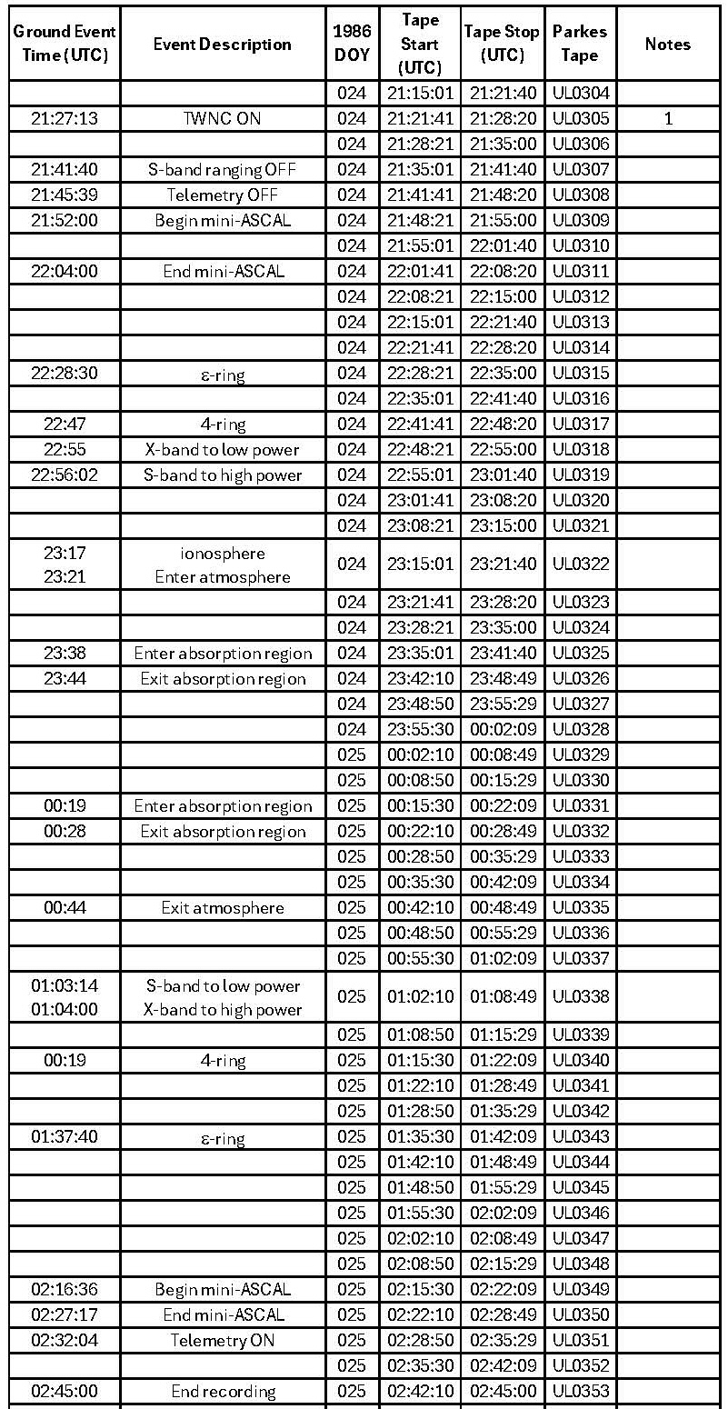
Open loop test data collected before the Voyager 2 Uranus encounter. Tape start and stop times are given in columns 4 and 5 — the beginning of the first and last records, respectively. Each record is 1 second. Tapes delivered to the Voyager Radio Science Team are listed in column 6 (Parkes Tape). Note 2: Record 4 on the original tape was short; it was padded to the correct length and a correct version of the binary file is included in the archive with the file name vg2u_49xr1986024t174101.dat.
